Bc"d

Submitted by Naor Eliav and Amir hoshen

***Perceptron algorithm***

In [machine learning](https://en.wikipedia.org/wiki/Machine_learning), the **perceptron** is an algorithm for [supervised learning](https://en.wikipedia.org/wiki/Supervised_classification) of [binary classifiers](https://en.wikipedia.org/wiki/Binary_classification). A binary classifier is a function which can decide whether or not an input, represented by a vector of numbers, belongs to some specific class. It is a type of [linear classifier](https://en.wikipedia.org/wiki/Linear_classifier). A classification algorithm that makes its predictions based on a [linear predictor function](https://en.wikipedia.org/wiki/Linear_predictor_function) combining a set of weights with the [feature vector](https://en.wikipedia.org/wiki/Feature_vector).

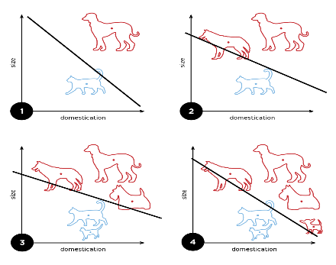This is an example of predicting whether the animal is cat or dog.

To learn and understand the algorithm I searched the internet and found a guide on the Udemi website and from there I also took the code and changed it. Attached is the source link: <https://www.udemy.com>.